Lecture No. 26 PARASITOLOGY DR.Raad H.H. Protozology
Family: Cryptosporidiidae
Genus Cryptosporidium
- Homoxenous
- Intracellular, but project from lumenal side of cell and attached to cytoplasm of host cell by Parasitophorus organelle "feeder organelle"
- Single Genus found Cryptosporidium
  - oocysts fully developed with 4 sporozoites, without sporocysts
  - Develop intracellulary, but in peripheral location on lumenal side of intestinal epithelial cell; projects into lumen
  - Two types of autoinfective stages hypothesized; type I merozoites capable of forming new type II meronts and thin walled oocysts that may liberate sporozoites to initiate new infections
  - Life-Cycle of Cryptosporidium parvum
    - oocysts ingested by host; in the case of Cryptosporidium parvum it usually involves neonates and over 150 different mammalian hosts have been found to be suitable
    - sporozoites excyst from suture at one pole
    - penetrate epithelial cells; preferred site ileum
    - type I meronts (with 8 merozoites); capable of recycling and producing more generations of type I meronts
    - some merozoites penetrate cells and undergo development into type II meronts with 4 merozoites
    - type II merozoites liberated, infect new cells
    - macrogametes and microgametocytes
    - 16 non-flagellated microgametes arise from microgametocyte; exit and penetrate macrogamete
    - zygote
    - resistant wall layed down around zygote; endogenous sporulation
    - about 20% oocysts thin walled, and may ruture releasing sporozoites to initiate new (autoinfective) cycles
    - exit with feces

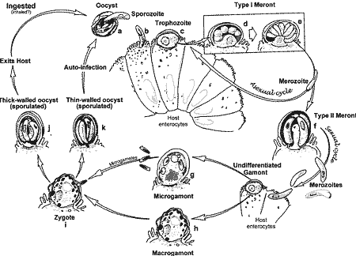

- Life-cycle ended when host immune response eliminates the reproductive cycle. If animal immunosuppressed, parasite overwhelms host due to recycling of type I meronts
- pathology involves severe diarrheal illness specially in calves , weight loss, abdominal cramping, and electrolyte imbalance
- Cryptosporidium is typically found in neonatal or young animals. Disease is not always present. Cryptosporidium, however, has been associated with clinical enteritis. In several hosts, including man and domestic animals, and with respiratory illness in man and domestic birds.
- Diagnosis is facilitated by identifying oocysts inthe feces with phase-contrast microscopy and several staining procedures formerly used for acid-fast bacteria
- Related Species
  - Cryptosporidium andersoni in gastric glands of cattle Cryptosporidium baileyi in cloaca and bursa of chickens
  - Cryptosporidium bovis in older calves Cryptosporidium canis in canids
  - Cryptosporidium felis in felids Cryptosporidium hominis in humans)
  - Cryptosporidium meleagridis in turkeys
  - Cryptosporidium molnari in fish
  - Cryptosporidium muris in gastric glands of rodents and other mammals
  - Cryptosporidium nasorum in Cryptosporidium saurophilum in reptiles, especially lizards (technically, this appears to actually represent Cryptosporidium varani)
  - Cryptosporidium scophthalmi in turbot
  - Cryptosporidium serpentis in gastric mucosa of reptiles, especially snakes Cryptosporidium wrairi in guinea pigs
- Epidemiology
- Cryptosporidiosis is a Zoonotic disease .
- Cryptosporidiosis is a water –born disease

